**Assisted Practice: 3.8 Create an EBS Snapshot**

This section will guide you to:

* Create an EBS snapshot

This lab has two subsection, namely:

3.8.1 Creating an EBS snapshot

3.8.2 Pushing the file to GitHub repositories

**Step 3.8.1:** Creating an EBS snapshot

* Select *Volume* in EC2 dashboard
* Click on *Action* -> *Create Snapshot*

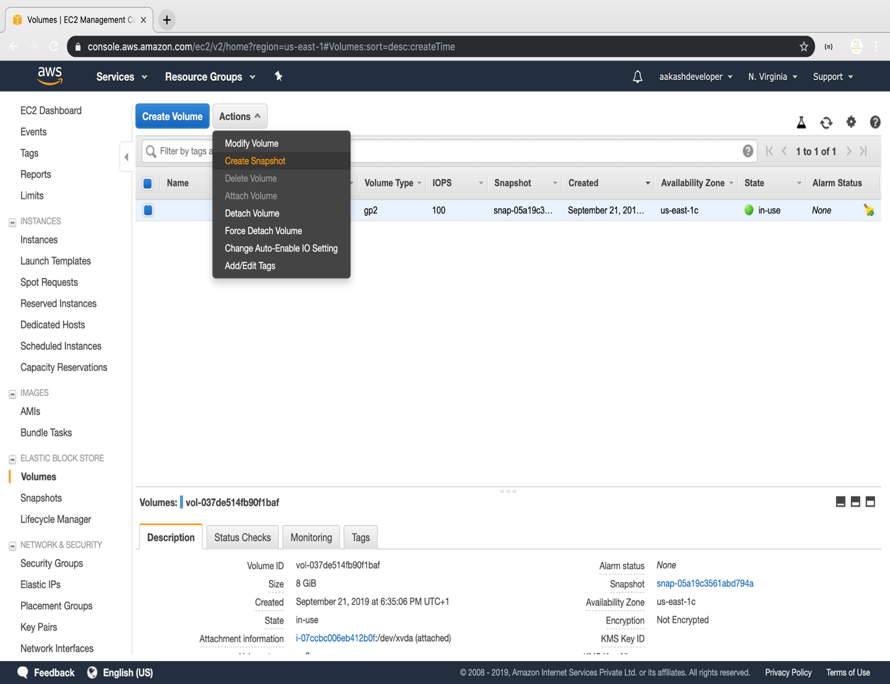

* Add snapshot name, key, and value

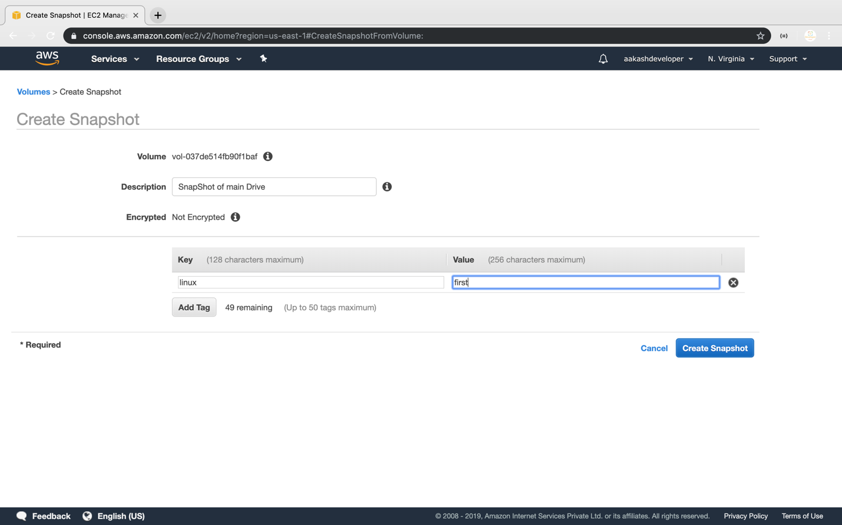

**Step 3.8.2:** Pushing the code to your GitHub repositories

* Open your command prompt and navigate to the folder where you have created your files.

**cd <folder path>**

* Initialize your repository using the following command:

**git init**

* Add all the files to your git repository using the following command:

**git add .**

* Commit the changes using the following command:

**git commit . -m “Changes have been committed.”**

* Push the files to the folder you initially created using the following command:

**git push -u origin master**